TravelGO Orbits
6D-20 To Tin Yan

Contents
1. Introduction 3
Purpose 3
Programming languages involved 3
Development Approach 4
Primary Goal 4
Tools and Techniques 4
Trade-off and Justification: 4
Timeline 4
2. Design and Implementation 5
Overall Color Scheme and Layout of the Webpage 5
1. Color Scheme and Visual Hierarchy 5
2. Typography and Readability 6
3. Layout and Spatial Organization 6
4. Visual Effects and Animation System 6
5. Navigation and Information Architecture 8
6. Responsive Design Implementation 8
7. Iconography and Visual Language 10
8. Technical Improvement 10
Connections 11
Database Connection 12
Utility Functions 12
Overall Login/Registration Process with Two-Factor Authentication 12
Introduction 12
1. Registration Process (register.php) 13
2. Authentication Handler (auth.php) 14
3. Two-Factor Authentication Setup (2fa_setup.php) 16
4. Two-Factor Authentication Verification (2fa_verify.php) 17
5. Login Interface (login.php) 17
6. Dashboard Management (dashboard.php) 19
7. Logout Handler (logout.php) 25
Ticketing Process 26
Introduction 26
1. Selecting Desired Criteria (index.php) 26
2. Displaying Search Results (search_results.php / search_results_roundtrip.php) 27
3. Payment Process (payment.php) 28
4. Check Digit Validation of Credit Card (Luhn Algorithm) 37
5. Supporting Files in Payment Process 38
3. Credits 42
1. Tailwind CSS 42
2. Feather Icons 43
3. Vanta.js 43
4. Google Fonts 43
5. Unsplash 43
6. UI Avatars 44

Introduction

Purpose
The purpose of this product is a website that offers an online airline ticketing service, which is named TravelGO Orbits, which provides flights for customers all around the world.

It allows our customers to search for available flights, check for its basic information, and purchase flight tickets online.

Programming languages involved
In this project, HTML, JavaScript and CSS and PHP are involved. This project's web application was developed and tested within a secure, local server environment using the XAMPP software stack, which includes MariaDB as it demonstrates better query performance, especially with complex queries and large datasets for ticketing services. This approach allowed for efficient, offline development, and data integrity before public release.

Development Approach

Primary Goal
The primary goal of the initial development phase was to achieve a high velocity for testing, evaluating, and refining the application's core features. To facilitate this, a deliberate decision was made to prioritize development speed over code structure.

Tools and Techniques
Tailwind CSS: This utility-first CSS framework was selected to expedite the UI construction process. By composing designs directly in HTML, it eliminated the context-switching between files and allowed for instantaneous styling adjustments.
Integrated JavaScript: JavaScript logic was written inline or within the same component files, rather than being separated into a modular architecture. This minimized the overhead of managing multiple script files and imports during the frequent and rapid changes inherent to the prototyping phase.

Trade-off and Justification:
It is acknowledged that this approach results in a higher degree of code complexity and tighter coupling between presentation, structure, and behavior. This is not considered a best practice for a large-scale, production-ready application. However, the trade-off was deemed acceptable for this specific self-development context. The significant gain in development speed, ease of debugging in a single location, and the ability to instantly test hypotheses directly contributed to a more efficient and effective evaluation cycle.

Timeline
The web application is under development for 6 months and divided into different phases:
Period | Phases
July | Define the scope, elements required for the project
Aug | Designing the frontend structure (HTML, CSS, JS) and schema of database
Sep | Writing modules for backend functions (PHP) and connections (MariaDB)
Oct | Testing functions to ensure consistency
Nov | Integration of frontend and backend structure with debugging
Dec | Further enhancement and refinement of algorithm

Design and Implementation

Overall Color Scheme and Layout of the Webpage
Executive Summary
The TravelGO Orbit homepage exemplifies modern web design principles with a sophisticated dark theme aesthetic that balances visual appeal with functional excellence. The interface employs a cohesive design language that establishes brand identity while ensuring optimal user experience through intuitive navigation, engaging visual elements, and responsive architecture.

1. Color Scheme and Visual Hierarchy
Primary Color Palette
Dark Theme Foundation:
- Background: Deep navy (#111827) creating a premium, focused environment
- Surface Elements: Layered transparency using rgba(255, 255, 255, 0.1) with backdrop blur effects
- Brand Accents:
  - Golden yellow (#f59e0b, #d97706) for primary actions and highlights
  - Electric blue (#3b82f6, #1e3a8a) for secondary elements and gradients
Color Psychology Implementation
- Trust & Security: Dark blue backdrop evokes reliability and professionalism
- Energy & Action: Yellow accents create visual urgency for CTAs and interactive elements
- Clarity & Focus: High contrast ratios ensure readability and reduce eye strain
Visual Hierarchy System
css
/* Text Hierarchy */
Primary Headers: #ffffff (white)
Secondary Text: #93c5fd (light blue)
Tertiary Text: #d1d5db (light gray)
Interactive States: #f59e0b (yellow)

2. Typography and Readability
Font System
Primary Font: Poppins (Google Fonts)
- Weights Utilized: 300 (Light), 400 (Regular), 500 (Medium), 600 (Semi-bold), 700 (Bold)
- Characteristics: Geometric sans-serif with excellent readability and modern appearance
Readability Enhancements
- Line Height: Generous spacing (1.5-1.75) for comfortable reading
- Text Shadows: Subtle implementation for depth and legibility over complex backgrounds

3. Layout and Spatial Organization
Whitespace Strategy
- Macro Whitespace: Large padding sections (py-16, py-32) between major content blocks
- Micro Whitespace: Consistent internal spacing (p-4, p-6) within components
- Visual Breathing Room: Strategic use of negative space to guide user attention
Component Layout Principles
css
/* Card-based Design */
.card-dark {
background: rgba(255, 255, 255, 0.1);
backdrop-filter: blur(10px);
border: 1px solid rgba(255, 255, 255, 0.2);
border-radius: 12px; /* Consistent rounded corners */
}

4. Visual Effects and Animation System
Vanta.js Globe Integration:
- Purpose: Creates immersive, dynamic background without distracting from content
- Configuration: Custom blue tones (0x3b82f6) against dark backdrop (0x111827)
- Performance: Optimized with mouse controls and responsive scaling
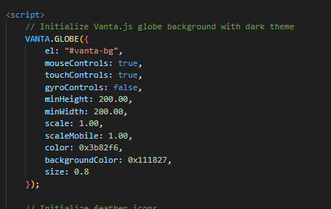
Micro-interactions and Transitions
Hover States:
css
.select-btn {
transition: all 0.3s ease;
}
.select-btn:hover {
transform: translateY(-2px);
box-shadow: 0 8px 25px rgba(245, 158, 11, 0.3);
}
Transform Effects:
- Scale Transformations: hover:scale-105 for button interactions
- Translate Movements: hover:-translate-y-1 for card elevations
- Rotation Animations: Airplane icon rotation for flight path visualization
Glass Morphism Design Trend
Implementation:
- Backdrop Filters: backdrop-filter: blur(10px) for frosted glass effects
- Transparent Overlays: rgba(255, 255, 255, 0.15) for layered depth
- Border Treatments: border: 1px solid rgba(255, 255, 255, 0.2) for subtle definition

5. Navigation and Information Architecture
Header Navigation Design
Fixed Navigation Bar:
- Sticky Behavior: Remains visible during scroll for constant access
- Visual Hierarchy: Logo prominence with secondary action alignment
User Account Integration:
- Profile Dropdown: Custom-designed with avatar display and smooth animations
- =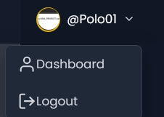

6. Responsive Design Implementation
Navigation Adaptation

- Desktop: Horizontal navigation with profile dropdown
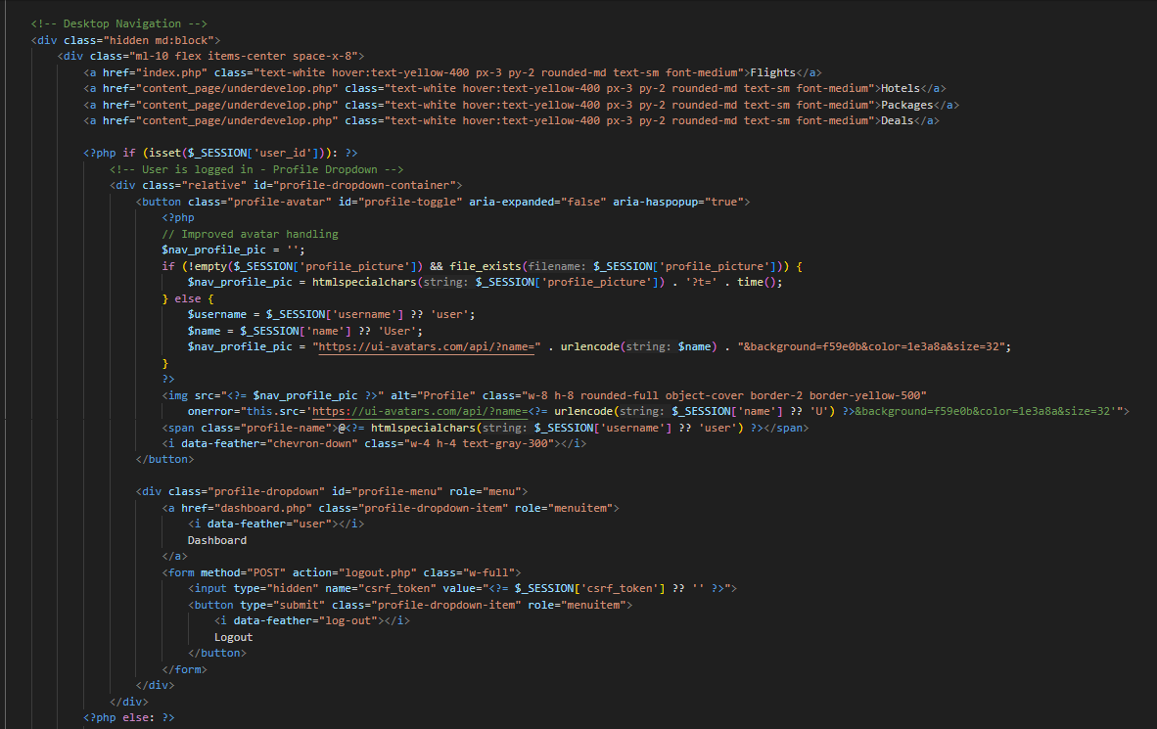
- Mobile: Condensed menu with mobile-specific profile controls
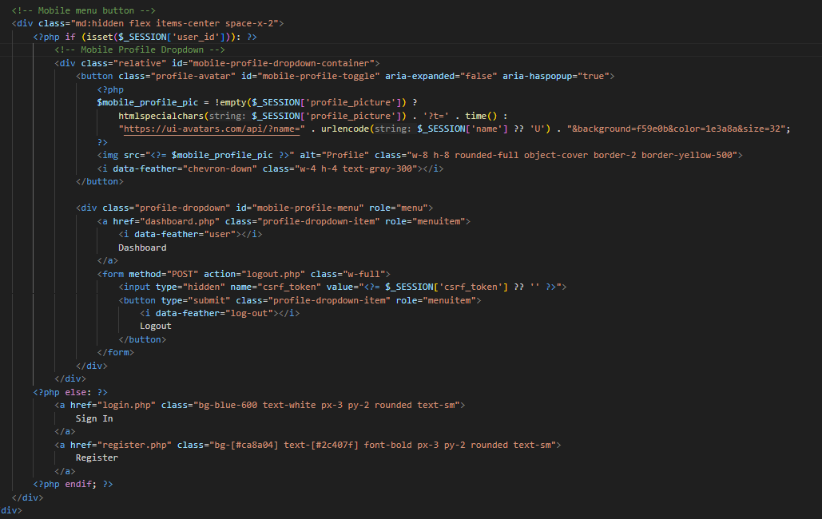

7. Iconography and Visual Language
Feather Icons Integration:
- Form Elements: map-pin, calendar, users for input labeling
- Availability: To maintain webpage consistency with collections of unified-styled icons



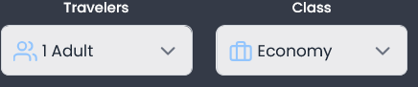
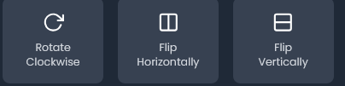
Icon Implementation:
- Size Consistency: Standardized dimensions (w-4 h-4 to w-8 h-8)
Background Illustration:
- Vanta.js Globe: Interactive 3D element that responds to user movement

8. Technical Improvement
CSS Efficiency:
- Tailwind CSS: Utility-first approach minimizing unused styles
- Custom Properties: CSS variables for maintainable theming
- Critical CSS: Above-the-fold optimization for perceived performance
JavaScript Performance:
- Lazy Loading: Dynamic content loading after initial render
- Event Delegation: Efficient event handling for multiple elements
Accessibility Compliance:
- Keyboard Navigation: Full tab-index support and focus management
- Screen Reader Support: Semantic HTML structure and ARIA attributes
Conclusion
The TravelGO Orbit homepage demonstrates a sophisticated design language that successfully merges aesthetic appeal with functional excellence. The dark theme implementation creates a premium, focused environment while maintaining excellent readability and usability. The consistent application of design principles across color, typography, layout, and interaction patterns establishes a strong brand identity and ensures a cohesive user experience.
Key strengths include:
- Visual Cohesion: Unified color scheme and consistent component styling
- User-Centered Design: Intuitive navigation and clear information hierarchy
- Technical Excellence: Performance-optimized implementation with accessibility considerations
- Modern Aesthetics: Contemporary design trends (glass morphism, dark mode) with timeless usability principles
This design language successfully positions TravelGO Orbit as a premium, trustworthy travel platform while maintaining the usability and functionality required for complex travel booking workflows.

Connections
It is a php script (connection.php) as a secure database connection and utility functions for all PHP functions. Below is a breakdown of its key functionalities:

Database Connection
It establishes a connection to the MariaDB database (travelgo) using PHP Data Objects (PDO), which is a secure way to interact with databases in PHP. $host, $db, $user, $pass, $charset are variables to store the database connection details.
For error handling, if the connection fails (\PDOException $e), it will:
- Log the error with error_log() (useful for debugging without exposing sensitive details).
- Redirect users to appropriate pages depending on their session status (dashboard.php for logged-in users, index.php for others).

Utility Functions
The script provides two reusable utility functions to enhance security and track client activity:
getClientIP(): To retrieves the user's IP address and handle scenarios where the IP might be proxied (e.g., through HTTP_CLIENT_IP or HTTP_X_FORWARDED_FOR headers).
CSRF Protection: CSRF (Cross-Site Request Forgery) protection is implemented through token generation and validation:
- generateCSRFToken(): To create a unique CSRF token and stores it in the session.
- validateCSRFToken($token): To validate the provided token against the one stored in the session using hash_equals() (secure comparison).
These functions are essential for securing forms and preventing malicious requests.

Overall Login/Registration Process with Two-Factor Authentication
Introduction
The authentication system for TravelGO Orbit implements a comprehensive and secure user registration and login process with optional two-factor authentication. The system is built with PHP backend functionality and features a modern, responsive interface using Tailwind CSS.

1. Registration Process (register.php)
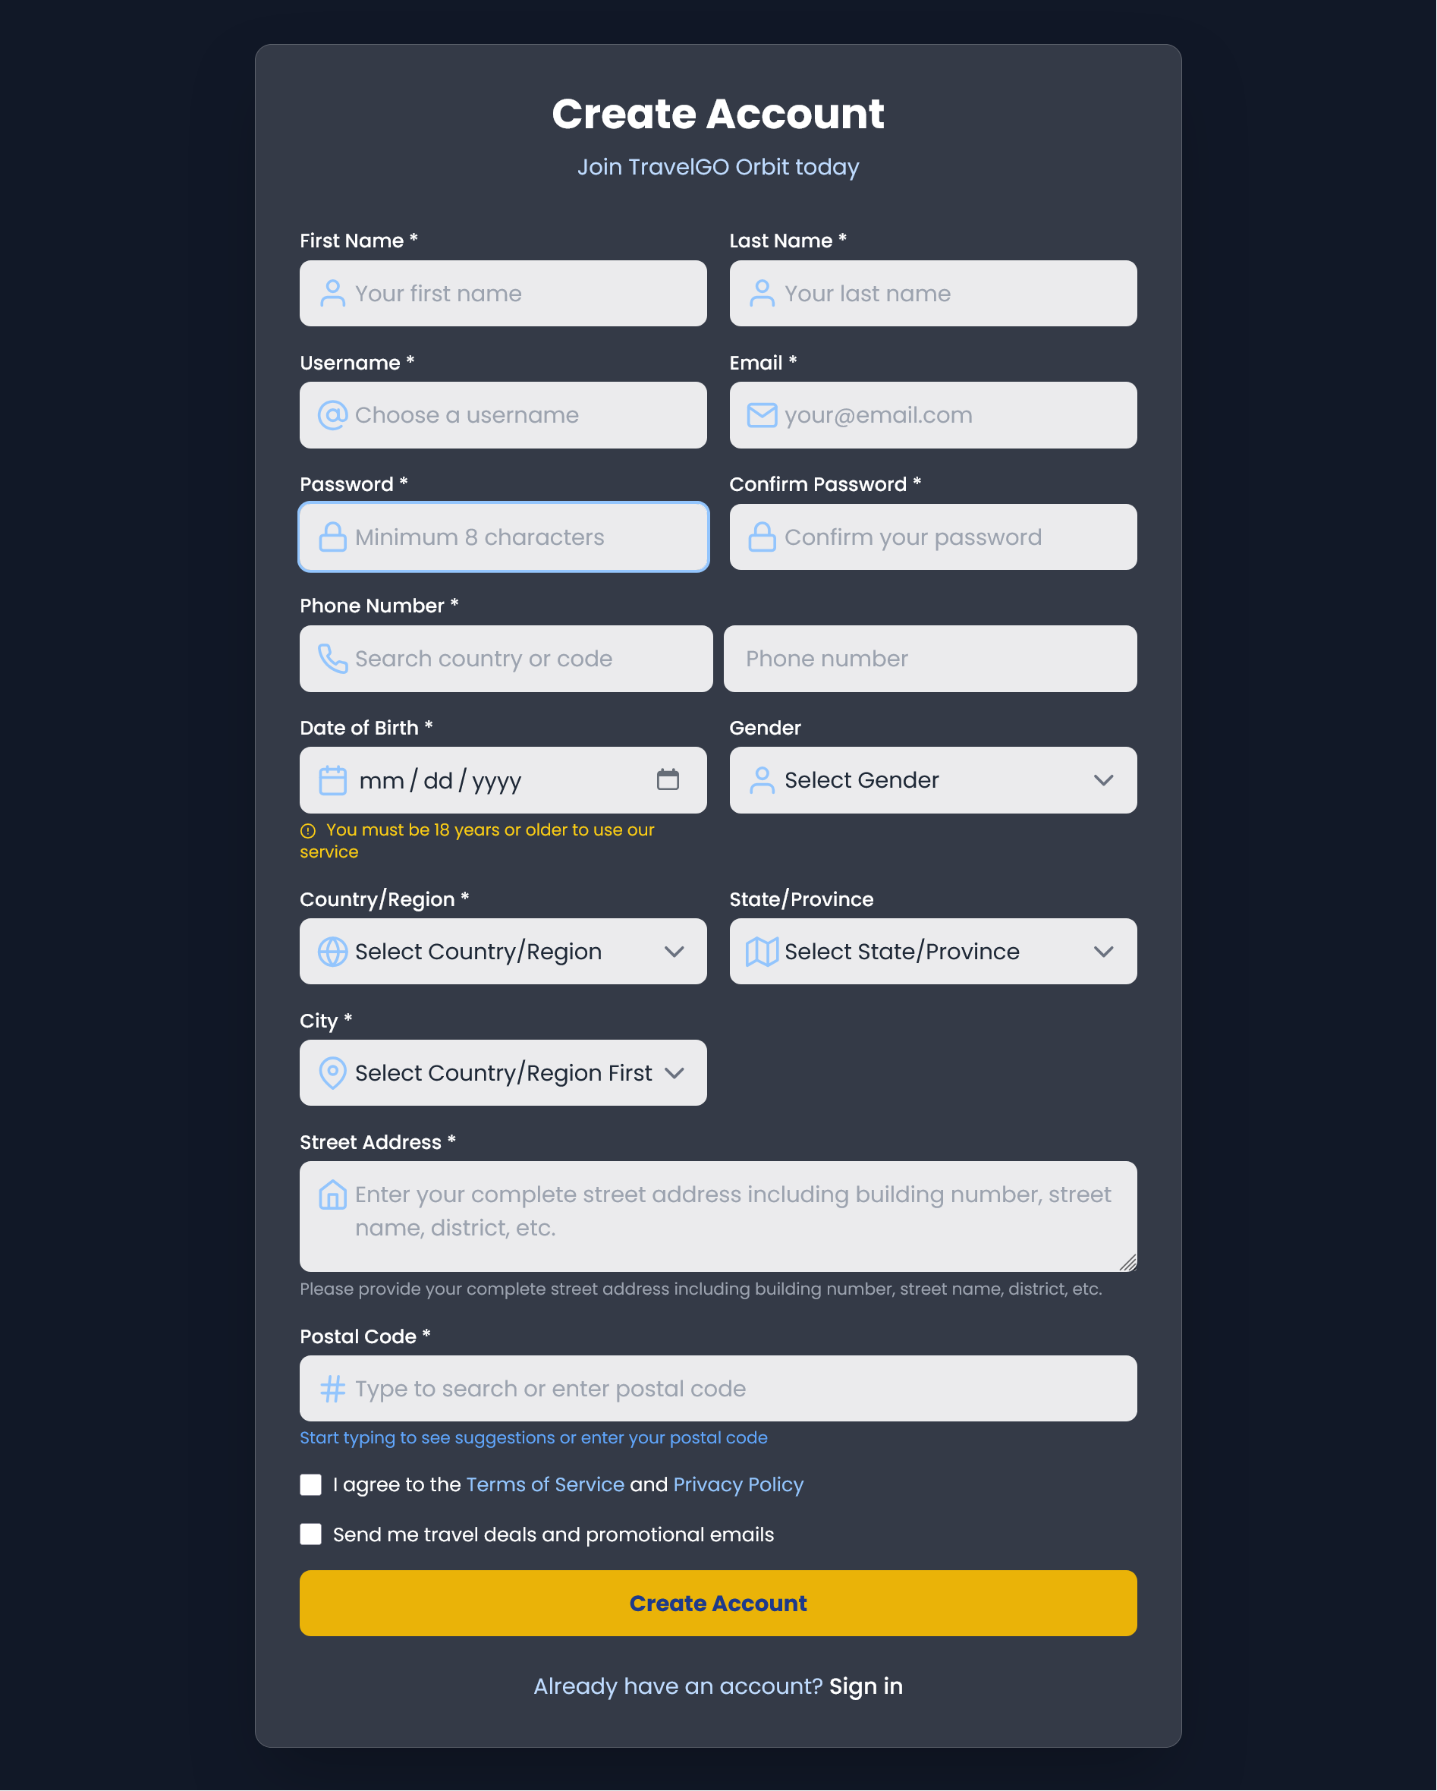
Purpose: Handles new user account creation with comprehensive data collection and validation.
Key Features:
- Multi-step registration form collecting personal, contact, and location information
- Real-time username availability checking via AJAX
- Searchable dropdowns for country codes and postal codes
- Age verification (18+ requirement)
- Phone number validation with international format support
- Dynamic location selection (Country → State → City)
- Terms of Service and Privacy Policy acceptance
- Newsletter opt-in option
Security Measures:
- Password strength validation (minimum 8 characters)
- Password confirmation matching
- Input sanitization and validation
- CSRF protection readiness
User Experience:
- Responsive design with intuitive form layout
- Progressive disclosure of form fields
- Real-time validation feedback
- Clear error messaging

2. Authentication Handler (auth.php)

Purpose: Central authentication controller handling both login and registration logic.
Login Process:
- Accepts both email or username for login
- Password verification using password_verify()
- Automatic redirection to 2FA verification if enabled
- Direct session creation for non-2FA users
Registration Process:
- Comprehensive input validation and error handling
- Email and username duplication checks
- Secure password hashing with password_hash()
- Automatic 2FA secret generation for new users
- Temporary session management for 2FA setup flow
Security Features:
- Prepared statements to prevent SQL injection
- Input filtering and sanitization
- Secure session management
- Error logging for debugging

3. Two-Factor Authentication Setup (2fa_setup.php)
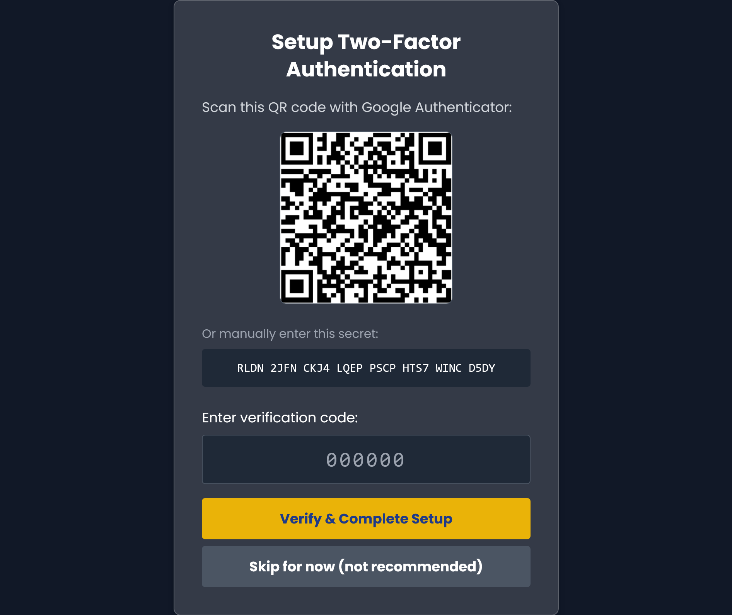
Purpose: Guides users through 2FA setup process after registration.
Key Functionality:
- QR code generation for Google Authenticator
- Manual secret key display as fallback
- TOTP code verification using the TwoFAAuth class
- Optional 2FA skipping (with security warning)
User Flow:
- Display QR code and secret key
- User scans QR code with authenticator app
- User enters 6-digit verification code
- System verifies code and enables 2FA
- User redirected to dashboard upon success
Security Implementation:
- Temporary session storage during setup
- Secure secret key generation
- TOTP code verification with time window
- Database update for 2FA status and secret

4. Two-Factor Authentication Verification (2fa_verify.php)
Purpose: Handles 2FA verification during login for users with 2FA enabled.
Process Flow:
- Intercepts login flow for 2FA-enabled users
- Presents clean verification interface
- Validates 6-digit TOTP codes
- Completes login process upon successful verification

User Experience:
- Minimal, focused interface for code entry
- Clear error messaging for invalid codes
- Back to login option for navigation

5. Login Interface (login.php)
Purpose: Primary user login interface with modern design.
Design Features:
- Glass-morphism card design with backdrop blur
- Feather icons integration
- Responsive layout for all devices
- Error message display area
- "Remember me" functionality
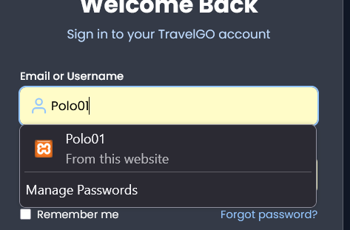

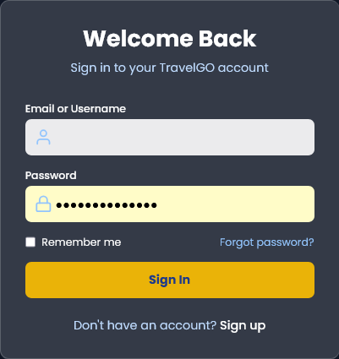

Functionality:
- Dual login capability (email or username)
- Form validation
- Clean error presentation
- Navigation to registration

6. Dashboard Management (dashboard.php)
Purpose: Comprehensive user dashboard with multiple functional views.

Dashboard Views:
- Overview: User statistics and quick actions
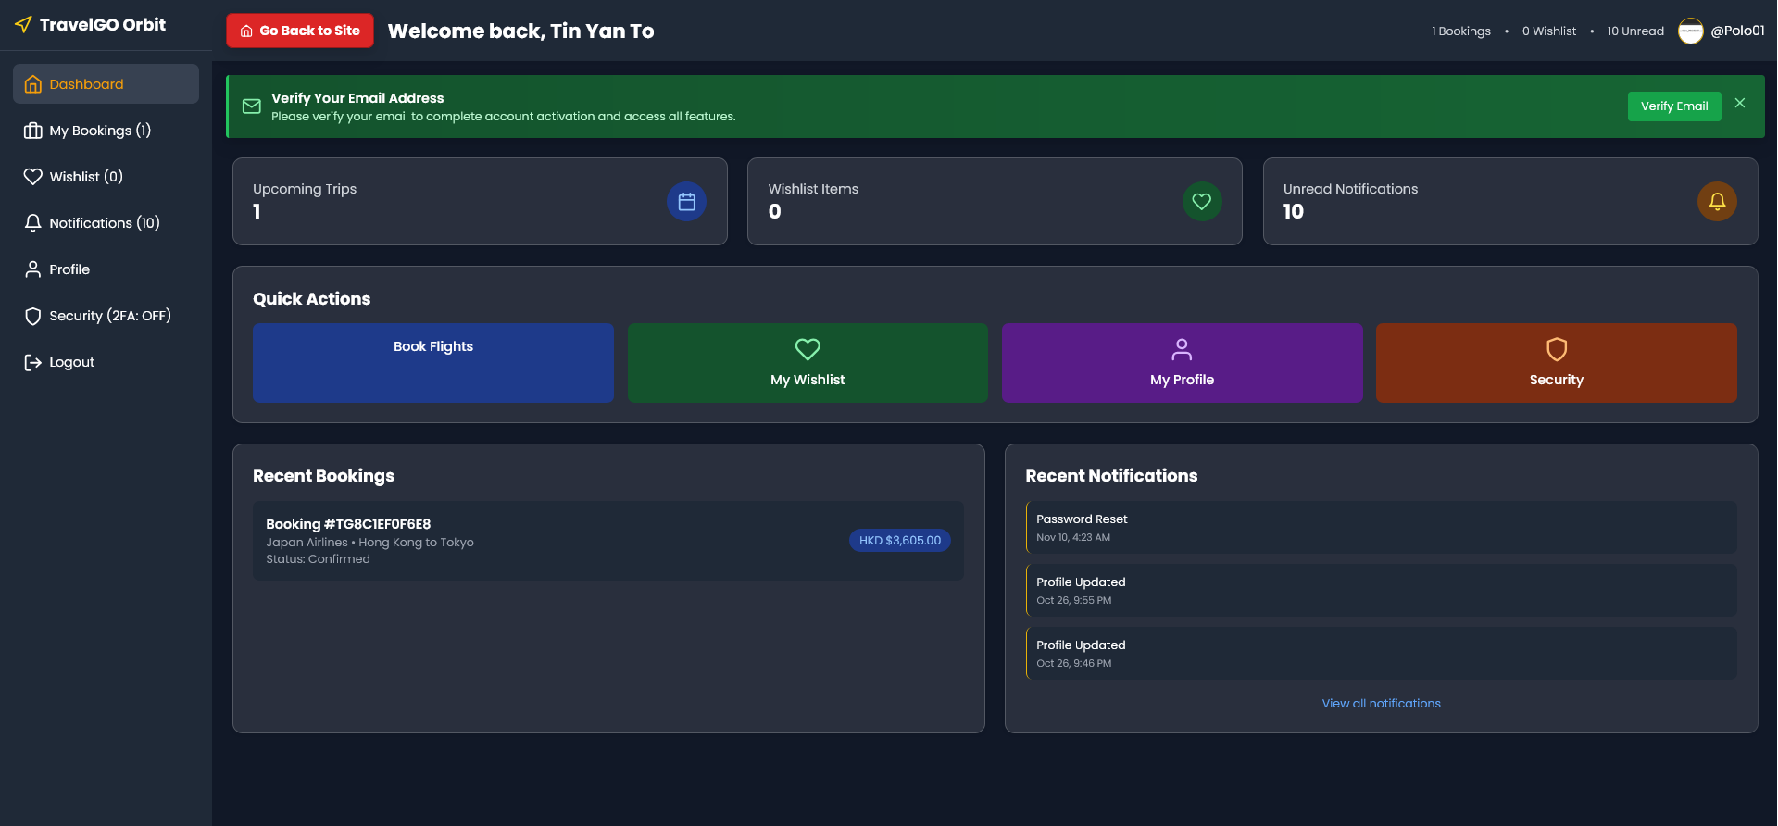
- Bookings: Flight booking history and details
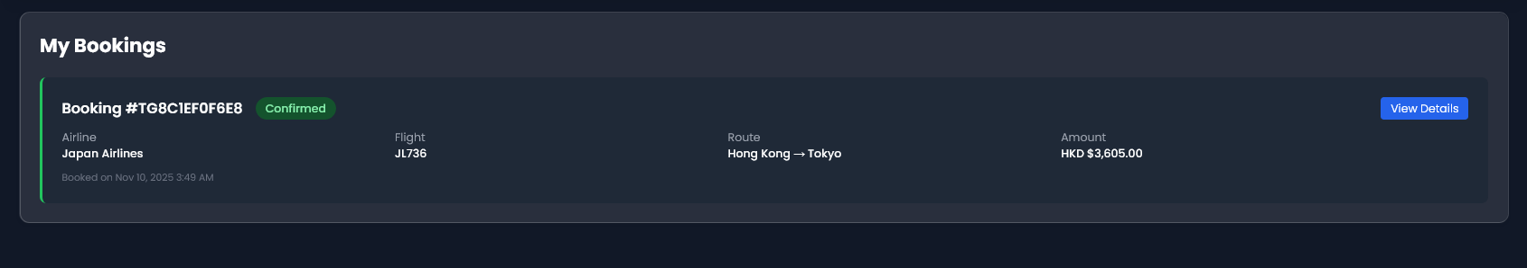
- Wishlist: Destination saving and management
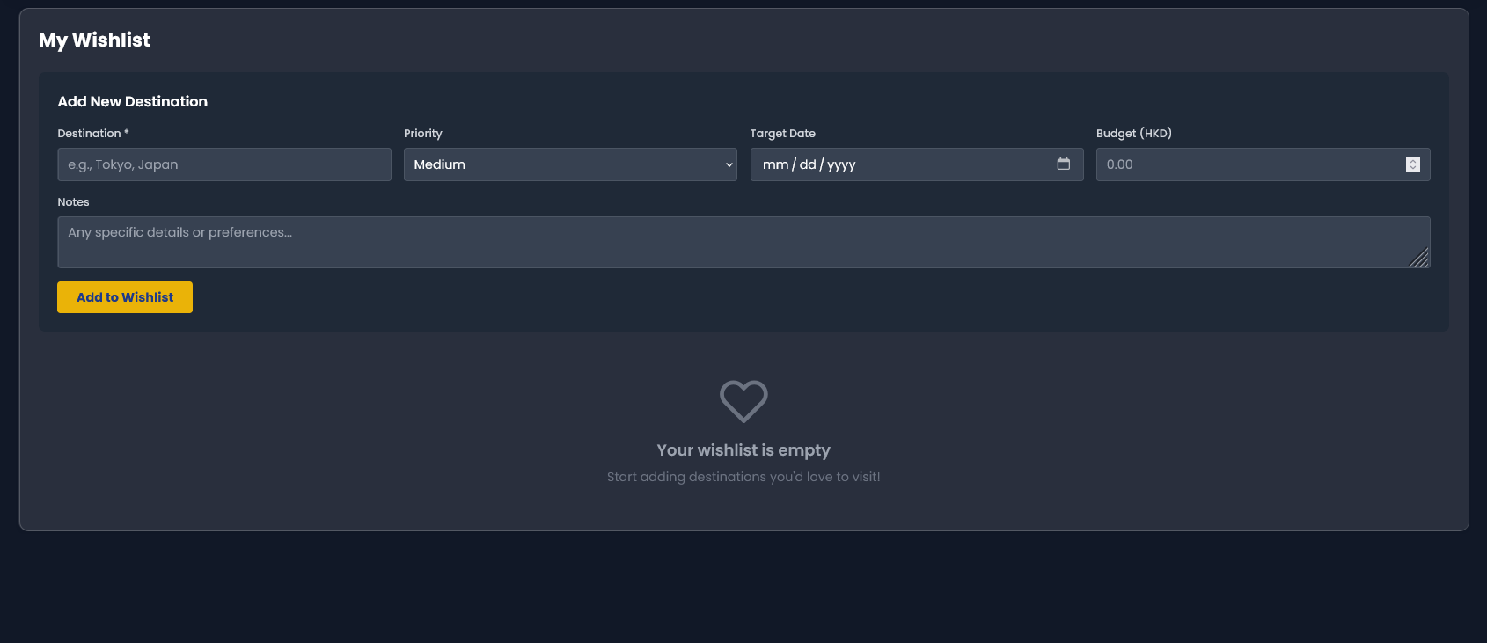
- Notifications: System and security notifications
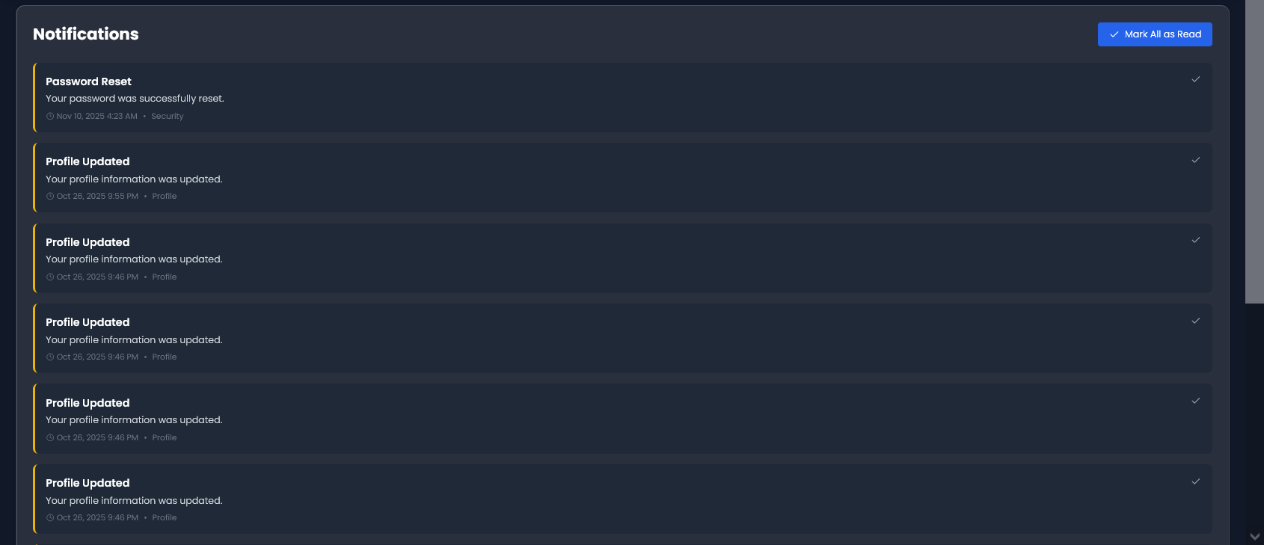

- Profile: Complete user profile editing
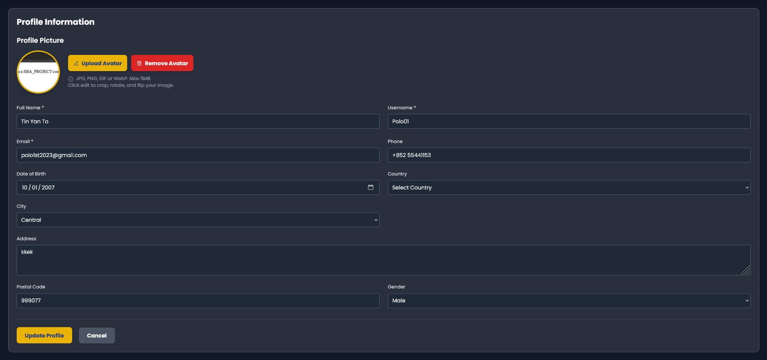
- Security Settings: 2FA and password management
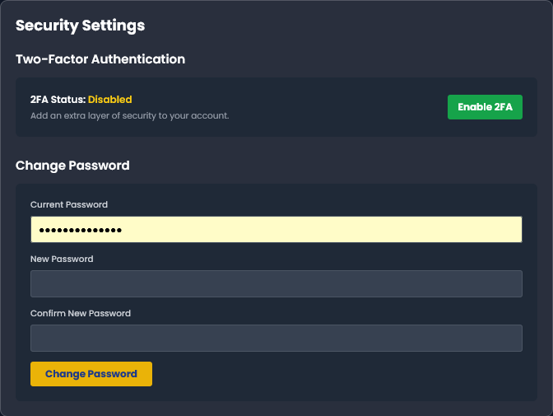

Advanced Features:
- Avatar Management:
  - Image upload with cropping interface
  - Real-time preview with rotation and flip controls
  - Client-side image editing before upload
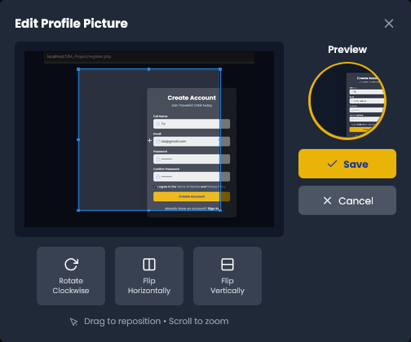
- 2FA Toggle: Enable/disable with confirmation modals
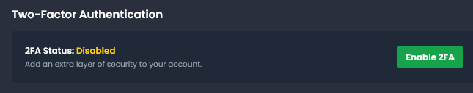
- Password Change: Secure password update flow
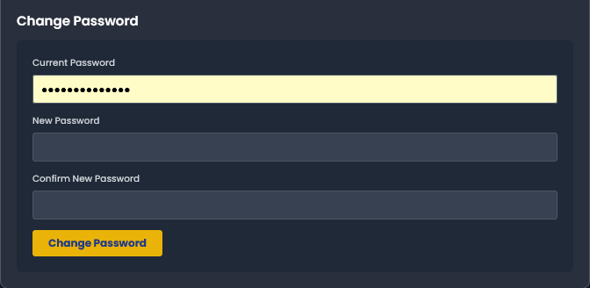
Security Implementation:
- CSRF token protection for all forms
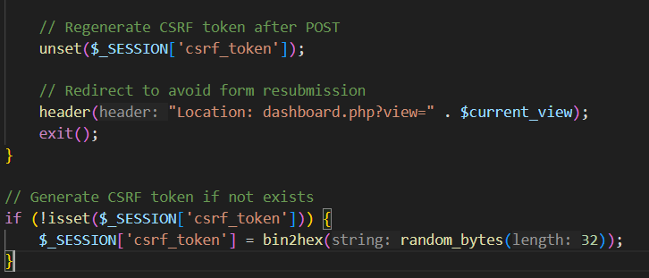

- Session validation on every load
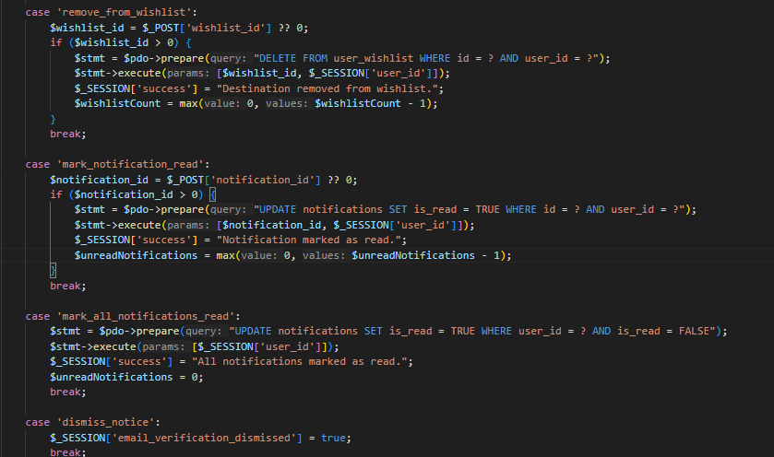

7. Logout Handler (logout.php)
Purpose: Secure session termination and cleanup.
Security Measures:
- Complete session data destruction
- Session cookie invalidation
- Redirect to home page
- Prevention of session fixation attacks

8. Password Recovery System (forgot_password.php)
Purpose: Multi-step password recovery process with security verification.
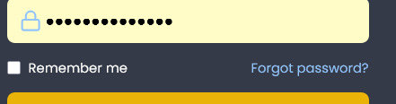
In login.php
Three-Step Recovery Process:
Step 1: Email Verification
- User enters registered email address
- System validates email format
- Security-conscious response (doesn't reveal if email exists)
- Progress indicator shows current step
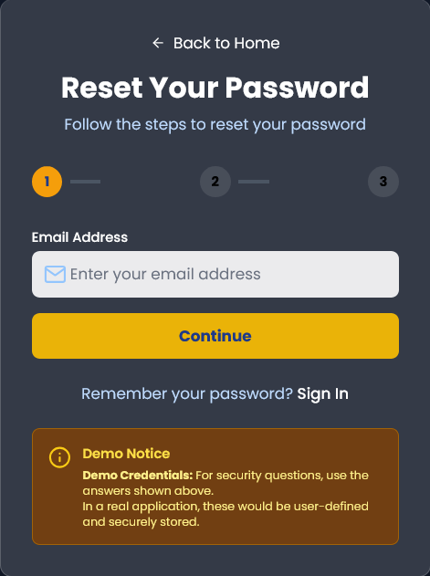
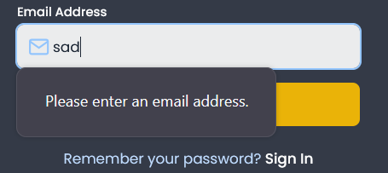
Step 2: Security Question Verification
- Random security question from predefined set
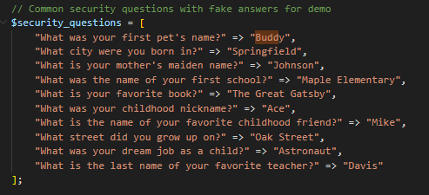
- Answer validation against expected response
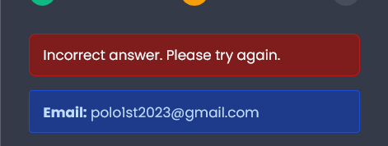
- Clear demo hints for testing purposes
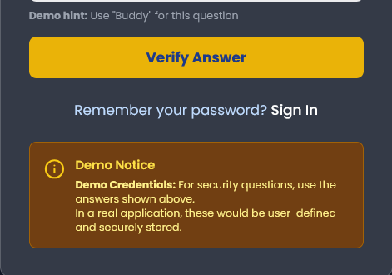
Step 3: Password Reset
- Inputting twice verification
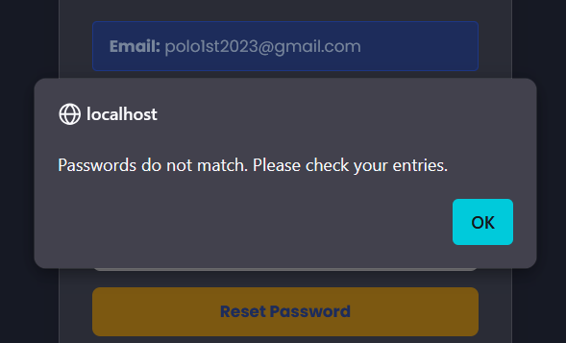
- Password strength validation (minimum 8 characters)
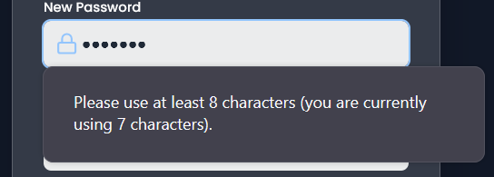
- Secure password hashing upon successful reset
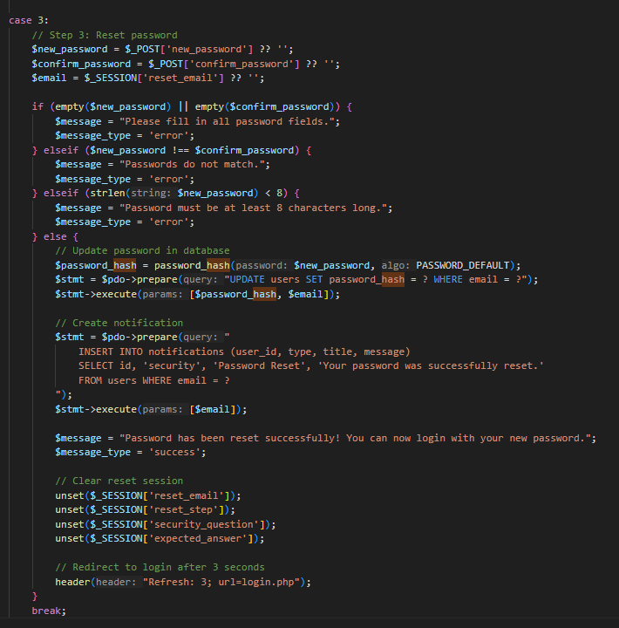
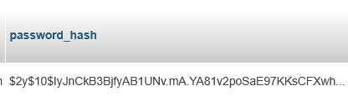
- Secure token to prevent reloading
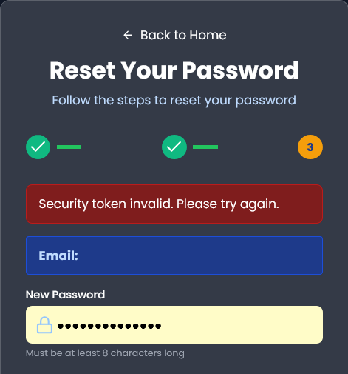
- Redirects back to index.php

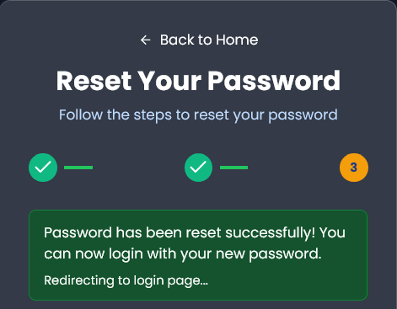
Security Features:
- Session Management: Secure step progression tracking
- Demo Security: Predefined questions/answers for testing

Technical Architecture
Security Implementation
- Password Security: bcrypt hashing with proper salt rounds
- 2FA Implementation: TOTP-based using RFC 6238 standard
- Session Management: Secure session handling with proper cleanup
- CSRF Protection: Token-based cross-site request forgery prevention
- Input Validation: Comprehensive server-side validation
Database Approaches
- Data Integrity: Foreign key relationships and proper data types
- Error Handling: Comprehensive exception handling and logging

Ticketing Process

Introduction
The flight ticketing process in TravelGO Orbit is a comprehensive, multi-step system that guides users from initial flight search to final booking confirmation. This seamless workflow combines intuitive user interfaces with robust backend processing to ensure a secure and efficient booking experience.

1. Selecting Desired Criteria (index.php)
Initial Search Interface
The flight booking journey begins on the main search page (index.php) where users specify their travel requirements through an intuitive form interface:
Key Search Parameters:
- Trip Type Selection: Users choose between Round Trip, One Way, or Multi-City options via an interactive toggle switch
- Location Input: Smart search fields for origin and destination with real-time suggestions from search_locations.php
- Date Selection: Calendar date pickers for departure and return dates with validation
- Passenger Configuration: Dropdown selection for number of travelers (1-5 adults or family option)
- Class Selection: Options include Economy, Premium Economy, Business, and First Class
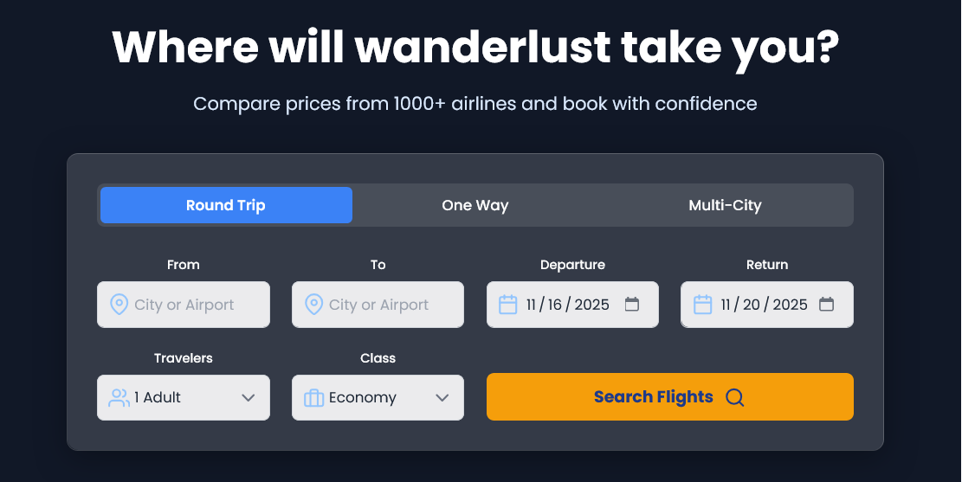
Data Submission Process
When users submit the search form:
- Form data is transmitted via GET method to maintain URL transparency
- The destination page is dynamically determined based on trip type:
  - Round Trip: search_results_roundtrip.php
  - One Way/Multi-City: search_results.php
- Example URL structure: search_results_roundtrip.php?from=Hong+Kong&to=Tokyo&departure=2024-12-15&return=2024-12-22&passengers=2&class=economy

2. Displaying Search Results (search_results.php / search_results_roundtrip.php)
Results Retrieval and Display
The application processes search criteria and presents available flights in a structured format:
Database Integration:
- Queries the database for matching flights using prepared statements
Results Presentation:
- Each flight card displays airline information, flight numbers, and timings
- Visual flight path representation with duration and stop information
- Clear pricing breakdown with total cost calculation
- "Select & Continue" buttons that pass flight details to the payment system
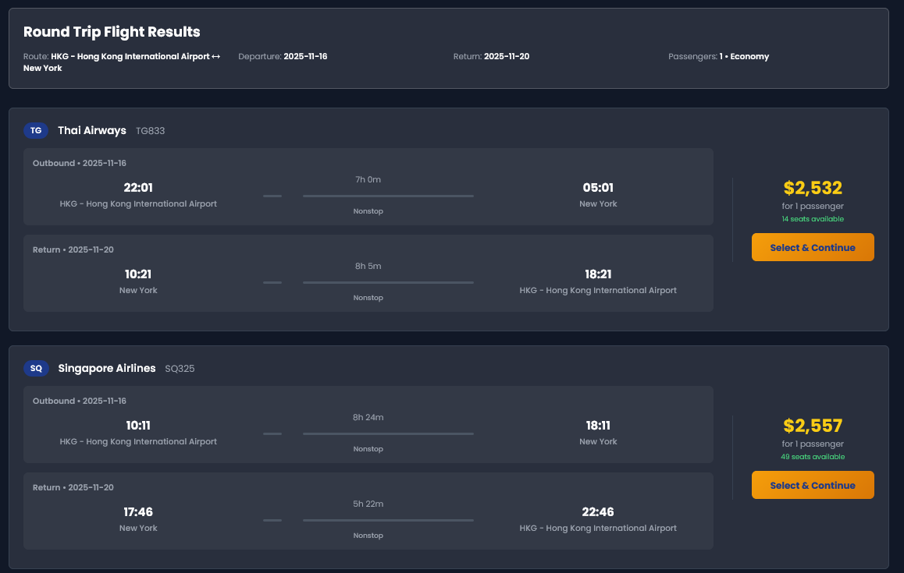
URL Parameter Handling
The GET method facilitates data transfer between pages:
- Flight selection redirects to: payment.php?flight_id=123&flight_type=round_trip&passengers=2
- This maintains state throughout the user journey without server-side sessions for initial steps

3. Payment Process (payment.php)
The payment system implements a six-step guided process that ensures complete data collection and validation:
Step 1: Passenger Information
- Collects personal details for all passengers (name, email, phone, gender, date of birth)
- Primary passenger receives additional validation requirements
- Option to auto-fill using profile data for registered users
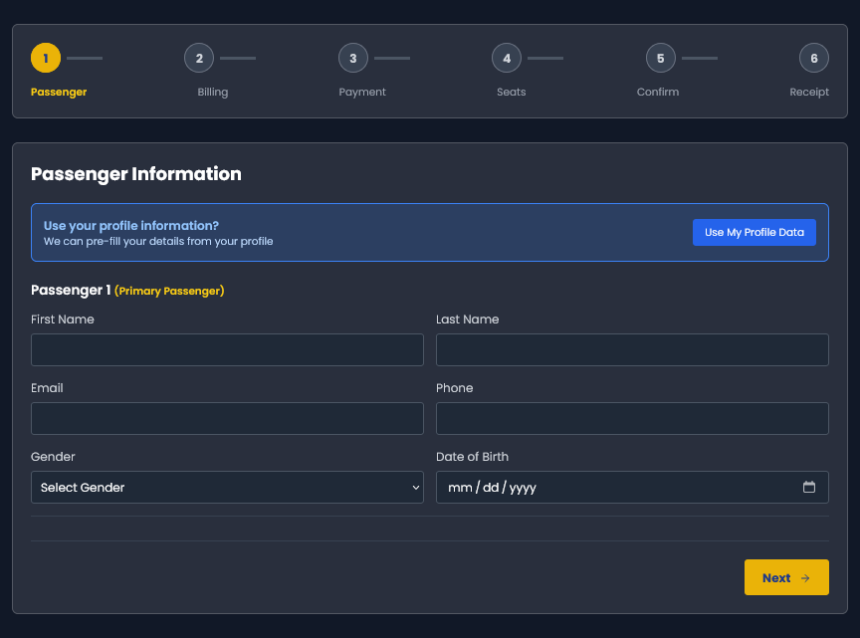
Step 2: Billing Address
- Comprehensive address form with street, city, state, ZIP, and country fields
- Integration with location services (get_states.php, get_cities.php) for dynamic dropdowns
- Profile data pre-filling capability
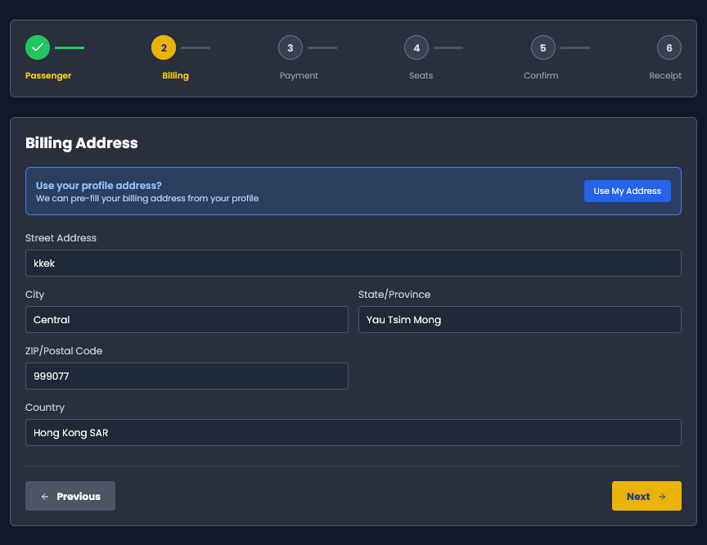
Step 3: Payment Method Selection
- Multiple payment options: Credit Card, Debit Card, PayPal
- Dynamic form fields that appear based on payment method selection
- Demo mode notification for development environment
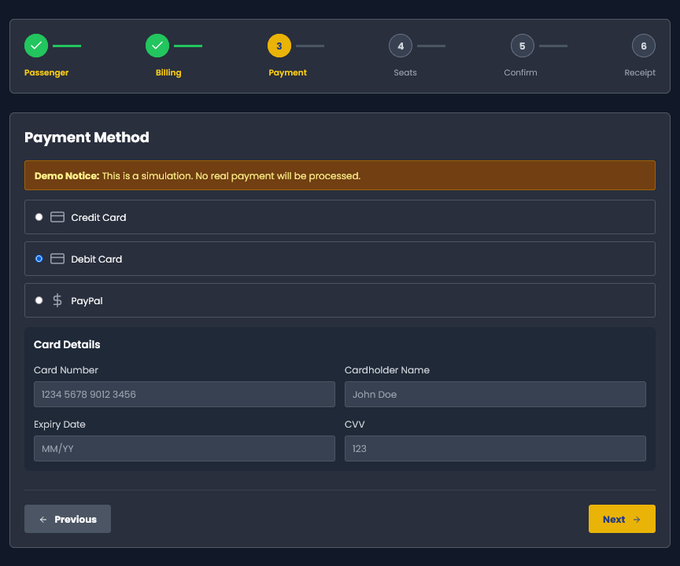
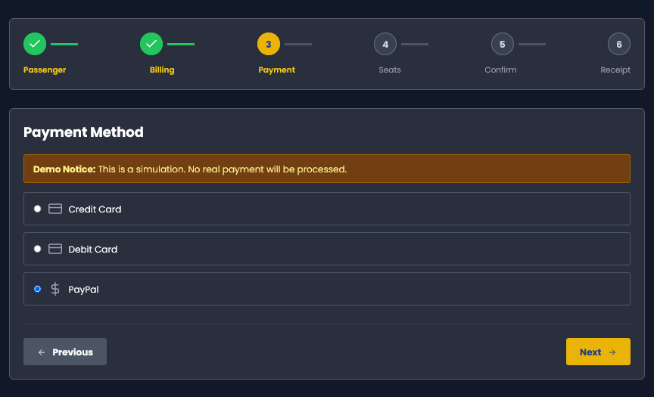
Step 4: Seat Selection
- Interactive seat map with visual representation of cabin layout
- Real-time seat availability and pricing (premium seats at extra cost)
- Validation to ensure correct number of seats selected
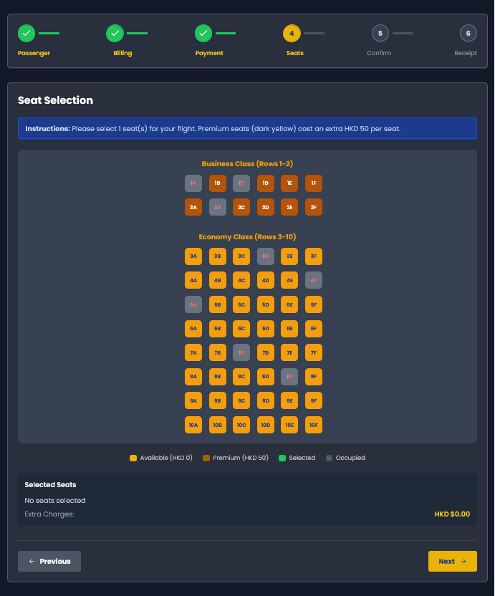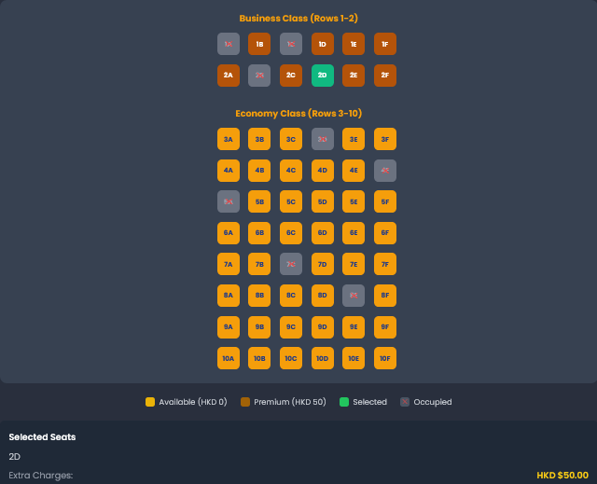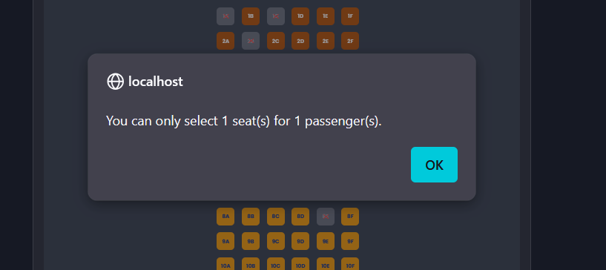
Step 5: Booking Confirmation
- Comprehensive review of all booking details
- Final cost breakdown including base fare, taxes, and seat charges
- User acceptance before payment processing
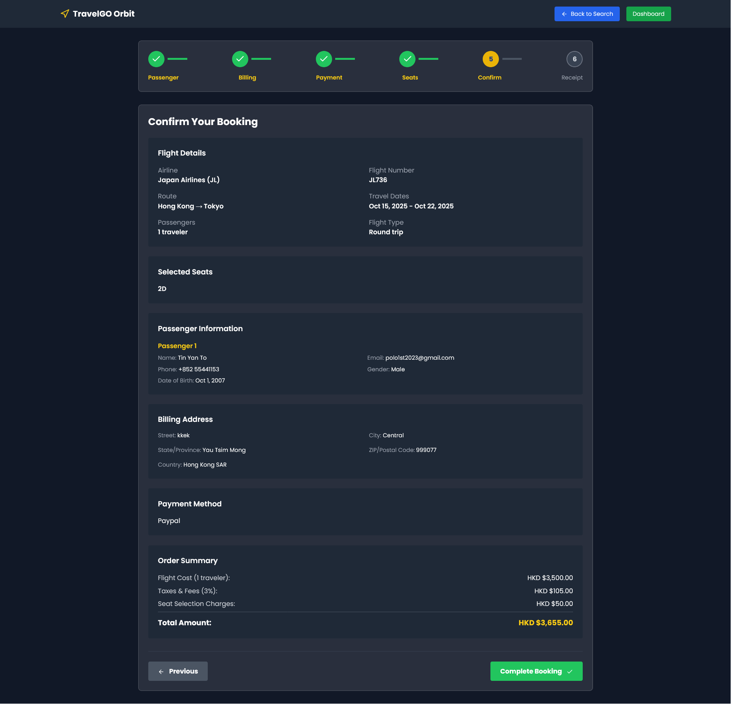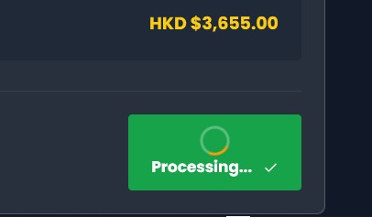
Step 6: Receipt Generation
- Immediate booking confirmation with unique reference number
- Detailed receipt including flight details, passenger information, and payment summary
- Options to print receipt or view in dashboard
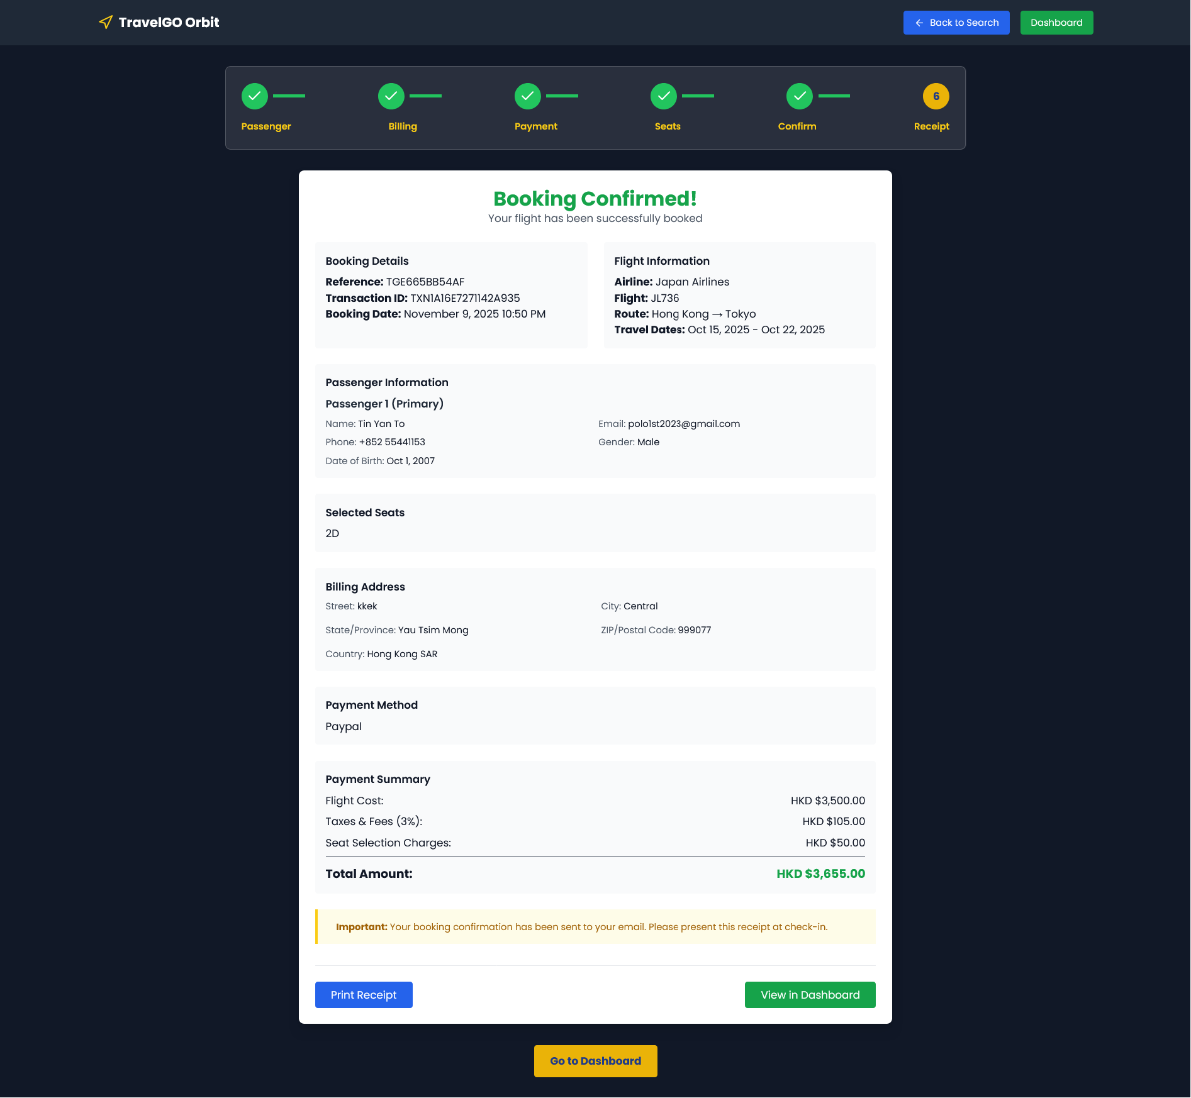
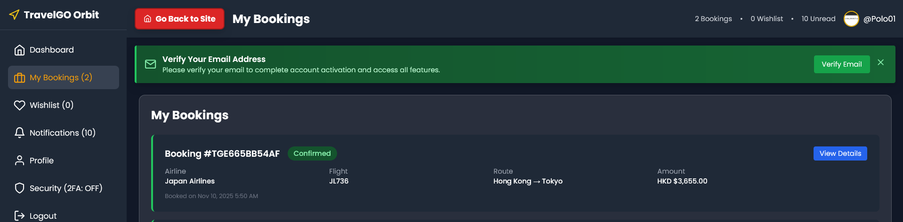

4. Check Digit Validation of Credit Card (Luhn Algorithm)
Implementation Overview
The payment system incorporates the Luhn algorithm to validate credit card numbers before processing:
Algorithm Steps:
- Digit Cleaning: Remove all non-digit characters from the input
- Length Validation: Ensure the number contains 13-19 digits
- Check Digit Calculation:
  - Starting from the right, double every second digit
  - If doubling results in a number greater than 9, subtract 9
  - Sum all digits (both doubled and unchanged)
- Validation Check: The total sum must be divisible by 10 for a valid card number
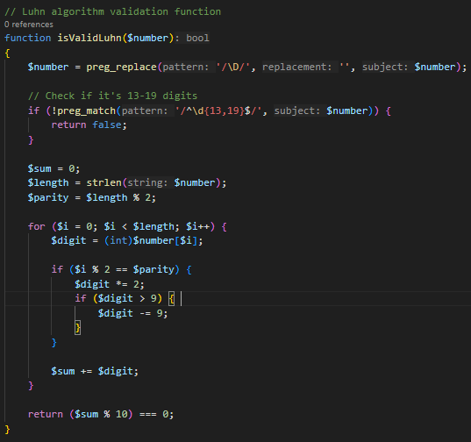
Importance and Benefits
- Error Prevention: Catches common data entry mistakes before payment processing
- Fraud Reduction: Provides initial screening against invalid card numbers
- User Experience: Immediate feedback prevents failed payment attempts
- Cost Efficiency: Reduces unnecessary payment gateway transactions

5. Supporting Files in Payment Process
Location Services
- get_cities.php: Returns city list based on country ID for dynamic dropdowns
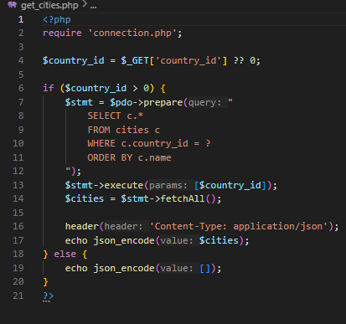
- get_states.php: Provides state/province data for selected countries
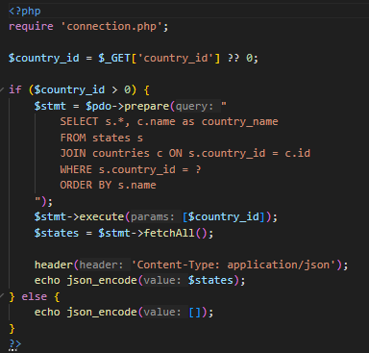
- search_locations.php: Powers the location search with autocomplete functionality
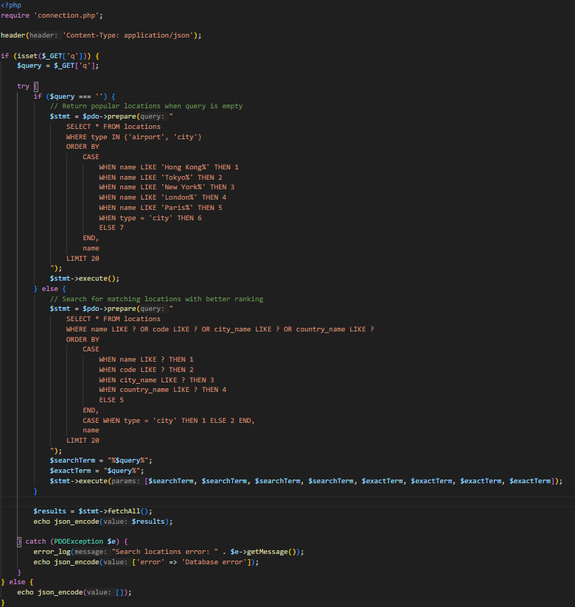
Data Retrieval
- get_destinations.php: Fetches trending and available destinations for display
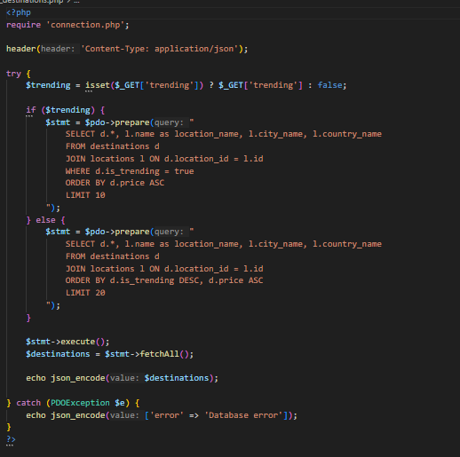
- connection.php: Database connection handler used across all payment-related files
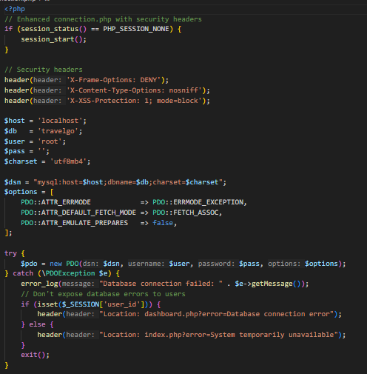

Credits

1. Tailwind CSS
File: All frontend files
Use: Utility-first CSS framework for rapid UI development
Source: https://www.tailwindcss.com
Purpose:
- Responsive grid system and layout utilities
- Pre-built component styling
- Consistent spacing and typography scale
- Dark theme implementation
- Interactive state classes (hover, focus)

2. Feather Icons
File: All frontend files
Use: Lightweight, customizable icon library
Source: https://feathericons.com/
Purpose:
- Navigation and UI icons (arrows, users, calendar, etc.)
- Form element decoration
- Action buttons and interactive elements
- Consistent iconography across the application

3. Vanta.js
File: index.php
Use: 3D animated background effects using WebGL
Source: https://www.vantajs.com/
Purpose:
- Interactive globe background on homepage
- Dynamic visual element that responds to mouse movement
- Premium visual appeal for hero section

4. Google Fonts
File: All frontend files
Use: Typography system
Source: https://fonts.googleapis.com/css2?family=Poppins:wght@300;400;500;600;700&display=swap
Purpose:
- Primary font family (Poppins) for all text content
- Improved readability and modern appearance

5. Unsplash
File: index.php
Use: Stock photography for testimonials
Source: https://unsplash.com/
Purpose:
- Authentic-looking user profile pictures

6. UI Avatars
File: index.php
Use: Dynamic avatar generation
Source: https://ui-avatars.com/api/
Purpose:
- Fallback profile pictures when custom images aren't available
- Avatar generation with user initials

